201 CMR 17.00 Compliance for Log360 Cloud
Strengthen cybersecurity and meet 201 CMR 17.00 compliance with Log360.
Region: USA | Type: Industry Standard | Category: Compliance | Pricing: Free

Overview
The 201 CMR 17.00 compliance extension in Log360 helps organizations meet Massachusetts 201 CMR 17.00, a state regulation requiring businesses holding MA residents' personal information to maintain a comprehensive written information security program with administrative, technical, and physical safeguards by providing centralized log management, access control monitoring, and security event detection. The platform supports 201 CMR 17.00 requirements for WISP management, user authentication, encryption compliance, firewall and endpoint protection, risk assessment, breach detection, and third-party vendor oversight.
For Written Information Security Program Management, Log360 audits policy changes, GPO configurations, and group memberships to verify that WISP controls are enforced and documented across the organization. To address Access Control and User Authentication, the platform monitors Windows and Unix logon events, failed logon attempts, AD logon records, and terminal service sessions to enforce authentication requirements. The extension also supports Encryption and Data Protection by providing capabilities that audits USB and removable disk activity, file system modifications, and cloud storage events to detect unencrypted personal data exposure.

Key Features
- Firewall, Antivirus, and Endpoint Security: Log360 monitors firewall policy compliance, antimalware events, Windows threat detection, and network attack alerts to enforce endpoint security requirements.
- Risk Assessment and Vulnerability Management: Log360 monitors system events, computer activity, and user behavior to support ongoing risk identification and assessment of existing security safeguard effectiveness.
- Access control and user authentication: Log360 monitors Windows and Unix logon events, failed logon attempts, Active Directory logon records, and terminal service sessions to enforce strong authentication and identify unauthorized access.
- Breach Detection and Incident Response: Log360 monitors network attack events, threat detection, malware activity, and Unix threat reports to enable rapid detection and documented response to security breaches.
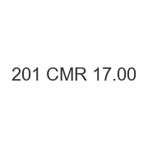
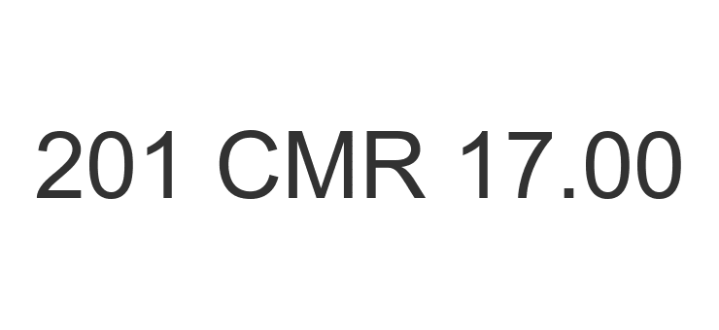
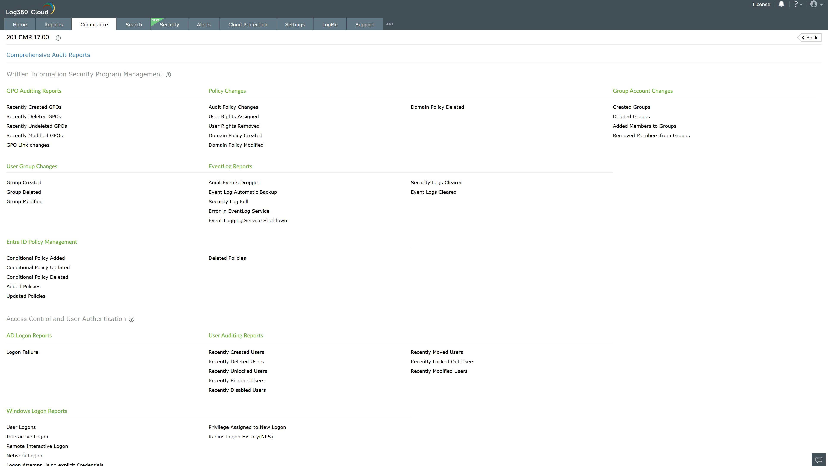
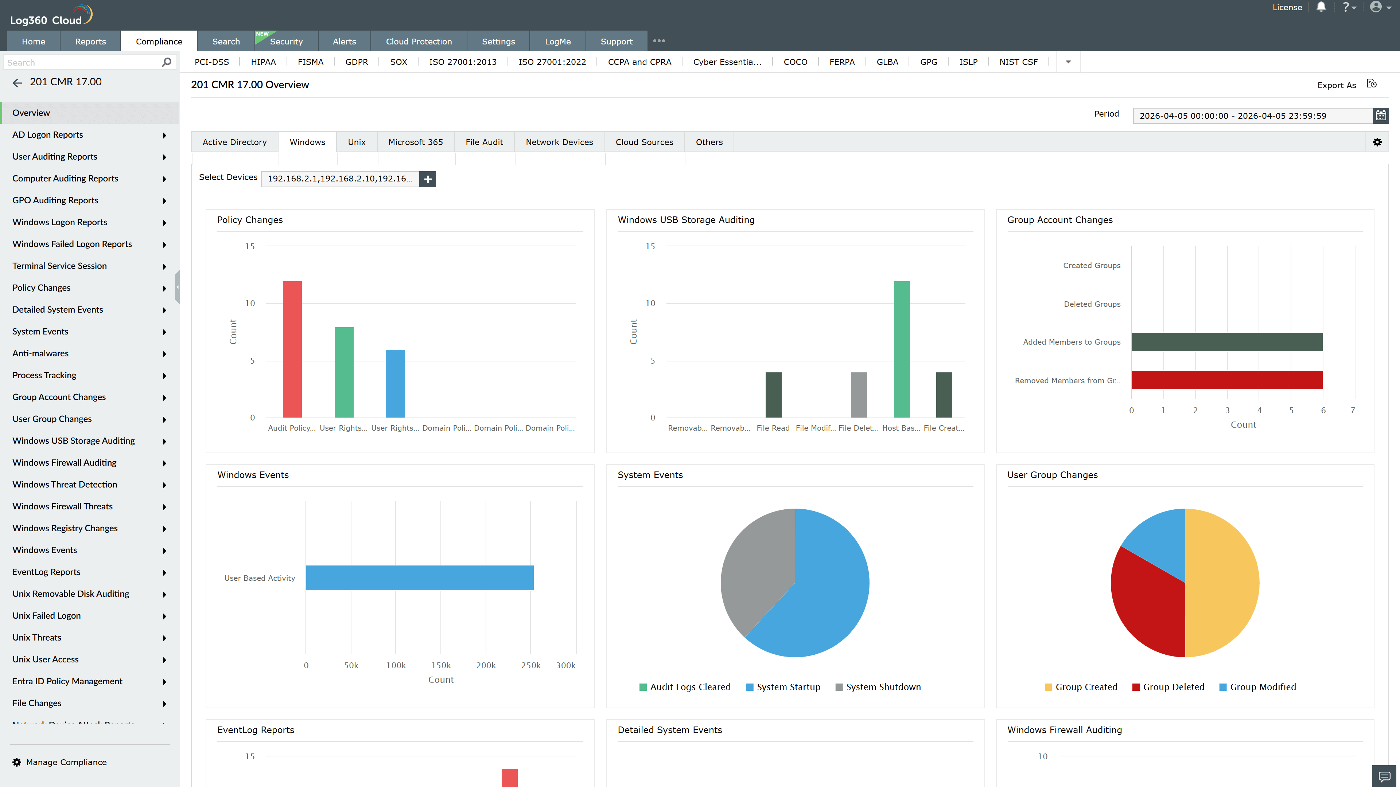
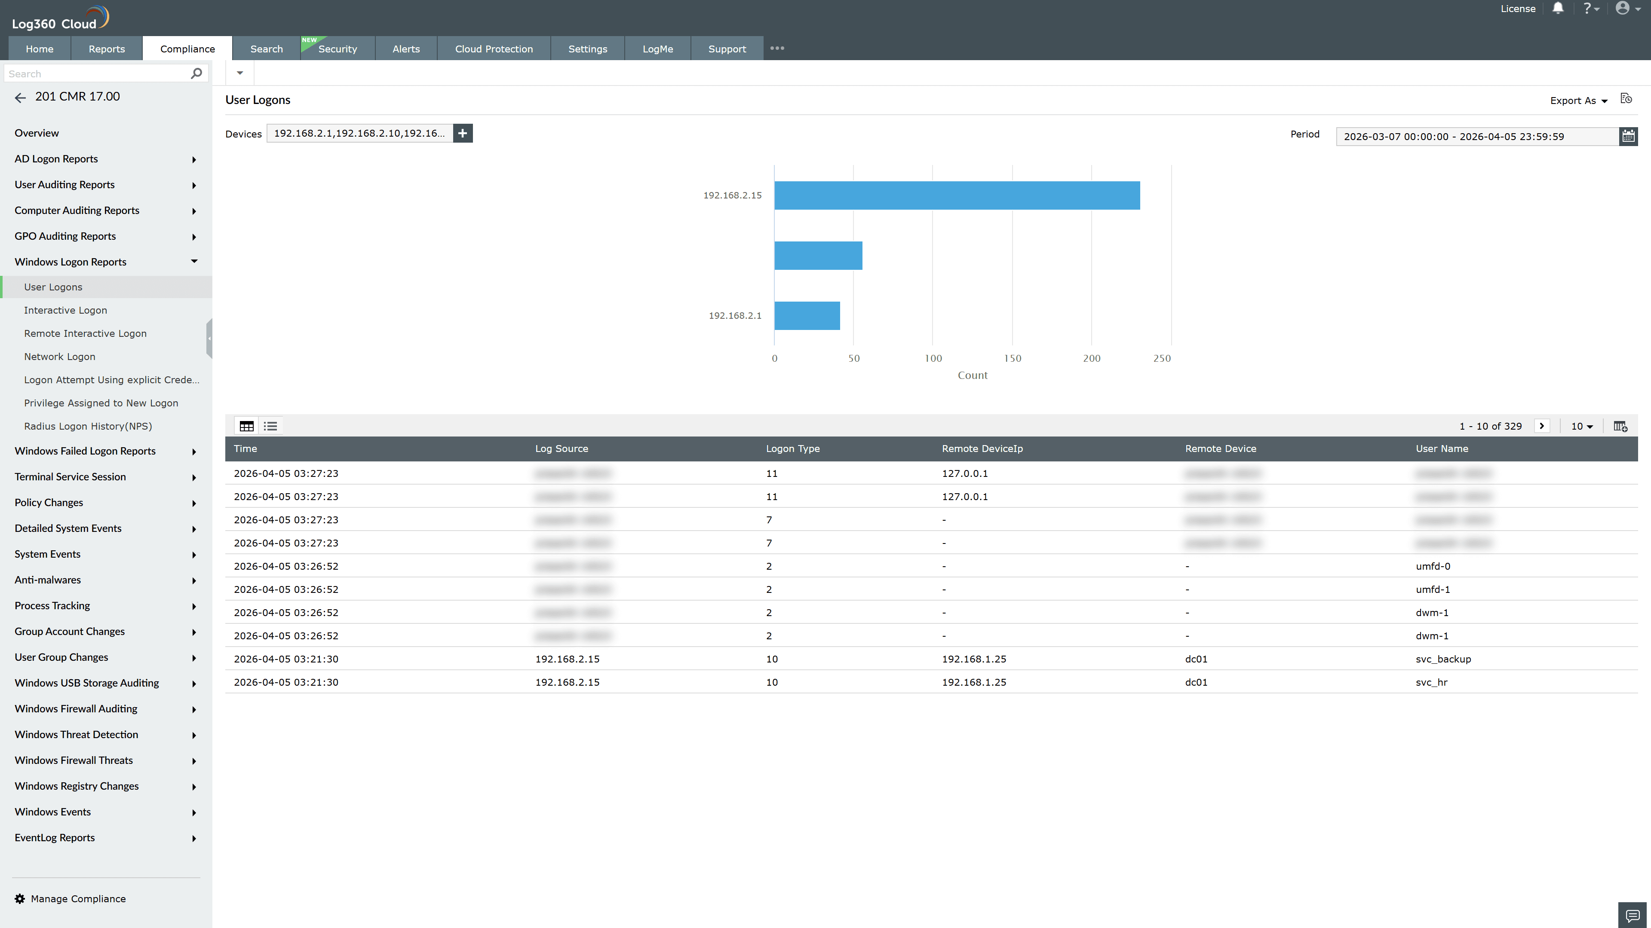
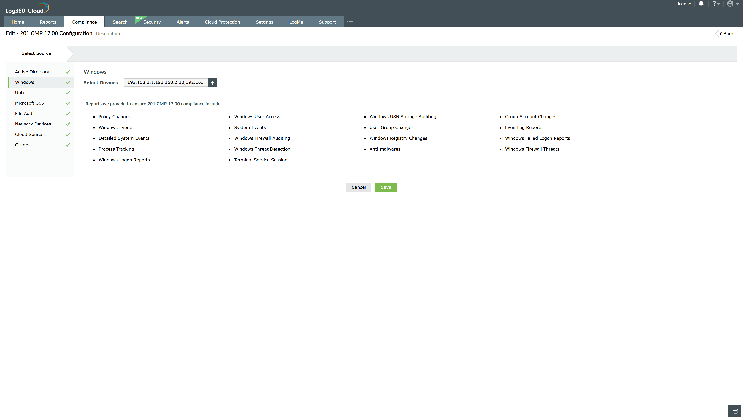
Valid Submission : Yes
Supported Editions : Free, Basic, Standard, Professional, MSSP
Help Document : https://www.manageengine.com/log-management/help/integrations/compliance-extensions.html
Help Video : Not provided
Tags : Log360, Compliance, Privacy monitoring, Data privacy, Regulatory compliance
Supported DCs : US, IN, JP, CA, AU, UK and EU
Privacy Policy:
Terms of Service:
Release Notes:
Predefined reports for the 201 CMR 17.00.

